Digital Operational Resilience Strategy

Policy Document

Department / Unit: <Department>
Version: 1.0
Effective Date: <Effective Date>
Approver: <Approver>
Approval Date: <Date of Approval>

Table of Contents

1 Purpose 3
2 Scope 3
3 Governance and Oversight 3
4 ICT Risk Management Framework 4
5 Operational Resilience Testing 6
6 ICT Architecture 7
7 Business Continuity and Disaster Recovery Strategy 8
8 Incident Management 9
9 Strategy for Third Party Risk Management 10
10 Budget Allocation and Resource Management 11
11 Monitoring and Review 11
12 Strategy Review and Update 11
13 Document History 11
14 Review History 12

Purpose
This strategy document is aligned with applicable regulatory frameworks on managing ICT risks, ensuring business continuity, and protecting critical assets. This document supports our commitment for operational resilience including preventing, detecting, responding and recovering from ICT incidents, minimizing downtime and disruptions and ensuring regulatory compliance. This document is designed to support and enable the overall business strategy by ensuring the resilience, security and availability of ICT systems that support critical operations. This strategy aims to ensure that:
- Uninterrupted delivery of services is achieved, even during ICT disruptions.
- The infrastructure supports innovation while minimizing operational risks.
- ICT risk management and resilience are integrated into business continuity and strategic planning.
- Compliance with regulatory and industry standards is maintained.
To ensure alignment with the business strategy, the following resilience objectives have been established:
- Operational continuity to ensure uninterrupted access to critical services.
- Protect customer data and ensure reliable service.
- Regulatory compliance to avoid penalties and reputational damage.
- Strengthening of digital resilience to meet regulatory requirements and stakeholders’ expectations.
- Implementation of proactive security controls to mitigate ICT risks.
- ICT resilience measures are integrated across all departments and functions.
- Regular reviews and updates to ensure that the reliance strategy evolves in line with business priorities and external threats.

Scope
The strategy is applicable to all ICT systems and data of the organization as well as employees, third-party vendors, and contractors handling ICT-related services.

Governance and Oversight
Governance and oversight are essential aspects of applicable regulations to guarantee the effective implementation and monitoring of all measures related to ICT risk management, resilience testing and incident response. The governance framework defines the following roles and responsibilities:
<Add Role Responsibilities> i.e.
- Senior Management
  - Approves the strategy and ensures its alignment with the business strategy.
  - Monitors the progress of strategy implementation, and regularly reviews progress reports.
  - Ensures commitment to resilience by integrating resilience across all levels of the organisation.
- Risk Management Committee
  - Oversees ICT risk assessments and ensures that risks are addressed promptly.
  - Reviews testing results and approves changes to resilience measures.
- IT Steering Committee
  - Ensures the comprehensive oversight and alignment with organizational objective.
- ICT Teams
  - Implement resilience measures, conduct tests, and report on system performance.
- Audit Function
  - Conducts independent reviews of resilience measures to ensure compliance with applicable regulations.

The governance and control framework includes the following components:

ICT Risk Management Framework
Effective risk management is crucial for maintaining the digital operational resilience of our organization. By identifying, assessing, and mitigating digital risks, we can ensure the continuity of our operations and safeguard our assets. This section outlines the structured approach we take to manage digital risks, including risk assessment, mitigation strategies, and continuous monitoring in order to risk levels to remain within the risk appetite of the organization.
<Company_Name> maintains an ICT Risk Management Policy and Procedure presented below.
<Add ICT Risk Management Practices> i.e.
- Risk Identification is performed through workshops with IT, security, and business unit leaders to identify potential digital risks.
  - Each risk’s likelihood and impact are assessed using a qualitative scale (e.g., rare, unlikely, possible, likely, almost certain) and a quantitative impact scale (e.g.: negligible, marginal, significant, critical, catastrophic).
  - Risks are categorized into Low, Medium, High, Severe based on their likelihood and impact.
- Risk evaluation is performed through the comparison of the identified risks against our organisation's risk appetite, which prioritises operational continuity and data security.
- Risk Mitigation involves the decision on the strategy to be followed for the mitigation of the identified risks including:
  - Risk Avoidance
  - Risk Reduction
  - Risk Transfer
  - Risk Sharing
  - Risk Acceptance
- Continuous Monitoring of risks by regularly reviewing them to update and re-assess risks.
The ICT management framework is supported by additional policies and procedures for monitoring and managing ICT risks across the organization. Key components of the framework include:
<Add Risk Management Policies> i.e.
- Incident Detection, Response and Recovery
  - Incident Management Policy
- Backup Policies and Procedures
  - IT Backup Procedure
- Vulnerability Assessment and Mitigation
  - Vulnerability Management Policy
- Business Continuity and Disaster Recovery
  - <Company_Name> Insurance Business Continuity Plans
  - ICT Business Continuity Policy
- Training and User Awareness
- Network and Operations Security
  - Logical Security Policy
- Patch Management
  - Patch Management Policy
  - Vulnerability Management Policy
- Human Resources Security
- Physical and Environmental Security
Physical Security Policy

A set of defined information security objectives have been defined within the digital operational resilience strategy and are monitored through measurable and attainable goals. These include:
<Add Objectives> i.e.
- Ensuring that information security is maintained throughout the operations by addressing the confidentiality, integrity and availability requirements of information assets.
- Robust oversight of ICT third party service providers.
- Defined risk tolerance levels in line enterprise risk.
- Implementation of robust automated and manual incident detection and response mechanisms to minimize impact and allow for effective and efficient recovery.
- Compliance with relevant regulations.
Information security objectives have been designed to ensure the protection across all elements of the confidentiality, integrity and availability, resilience, and reliability. These objectives align with the requirements of applicable regulations to safeguard information assets.
To achieve these objectives the organization implements controls in the following categories:
<Add Controls> i.e.
- Access Controls
  - Access rights, Role-Base Access, PAM, Internal Firewalls
- Endpoint Security
  - Antivirus, and XDR
- Network Security
  - IDS, IPS, VPN
- Data Protection
  - Encryption
- Incident Detection
  - SIEM, anomalies detection, log analysis
- Incident Response and recovery
  - Incident response simulation, IR plans/playbooks

Operational Resilience Testing
Digital operational resilience testing is a critical component of this strategy and involves the rigorous and systematic testing of our ICT systems, processes, and personnel to ensure preparedness against potential disruptions. This section outlines our approach, methodologies, and key areas of focus in conducting resilience testing as part of our compliance with applicable regulations.
The main objective of the Operational Resilience Testing is to evaluate the readiness of <Company_Name> to detect respond and recover from ICT-related incidents, to proactively identify weaknesses and deficiencies in operational resilience and to implement corrective measures promptly.
<Add Resilience Testing Practices> i.e.
The high-level testing framework includes:
- Validation of security measures
Includes the assessment of the implemented mechanisms to prevent or mitigate disruptions including various types of tests such as penetration testing, vulnerability assessments and disaster recovery testing.
- Identification of vulnerabilities in ICT systems or processes.
- Regulatory compliance to ensure adherence to regulatory requirements.
- Business continuity testing.
Test results are analysed, and feedback is incorporated into our resilience strategies to drive continuous improvement by updating security controls, improving incident response plans and enhancing employee training programs based on the gaps identified.
A comprehensive Digital Operational Resilience Testing Framework including the testing program has been defined and approved by the Management (ref: “<Company_Name> Insurance - Digital Operational Resilience Testing Program”)

ICT Architecture
This section provides information on the current capabilities of the organization to ensure operational resilience and compliance with applicable regulations, including the ability to support the business objectives and have adequate capabilities to detect, respond and recover from ICT disruptions.
The organization has implemented measures to support ICT reliance including:
<Add Operational Resilience Status> i.e.
- High availability infrastructure to support operations during a disruption.
- Risk assessment for the identification and mitigation of ICT risks.
- Partnerships with third party providers for hosting, disaster recovery and network security.
The next section provides a more detail view of our current resilience status:
Network Infrastructure
<Add Network Infrastructure Resilience Practices> i.e.
Redundancy: We have implemented multiple redundant paths to ensure network availability during outages. This includes secondary and tertiary network connections from different providers.
Performance Monitoring: Continuous monitoring of network performance is conducted to proactively identify and address issues.
Disaster Recovery: Network components are configured to switch to backup systems seamlessly in the event of a failure.
Data Centers
<Add Data Centers Resilience Practices> i.e.
Backup Power: Equipped with uninterruptible power supplies (UPS) and backup generators to maintain operations during power outages.
Fire Suppression Systems: Fire detection and suppression systems are in place to protect hardware and data.
Data Backup and Recovery
<Add Data Backup and Recovery Practices> i.e.
Regular Backups: Data is backed up regularly and stored both on-site and off-site. Critical data undergoes half-hourly replication backups to the DR site, while the whole company systems and data are backed up daily.
Recovery Testing: Regular disaster recovery testing is conducted to ensure data can be restored swiftly and accurately in the event of a data loss.
Secure Storage: Backup data is encrypted and stored in secure locations to prevent unauthorized access.
Cybersecurity Measures
<Add Cybersecurity Measures> i.e.
Threat Detection: We use advanced threat detection systems to monitor for and respond to potential cyber threats in real-time.
Firewalls & Anti-Virus: Robust firewalls, intrusion detection systems (IDS), and antivirus software are used to protect against external and internal threats.
Employee Training: Regular quarterly cybersecurity training sessions are conducted to ensure all employees are aware of best practices and potential risks.
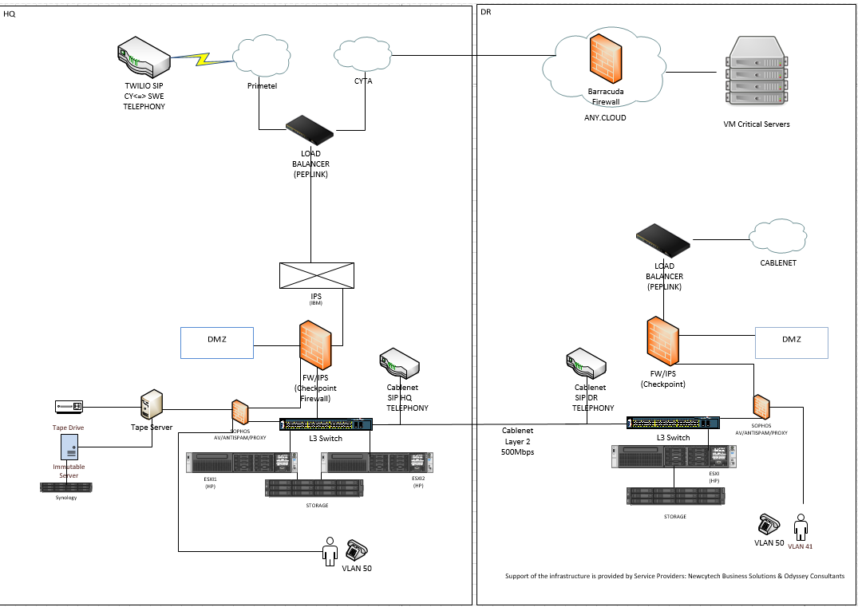

Business Continuity and Disaster Recovery Strategy
Business Continuity Planning (BCP) is essential to ensure that our organisation can continue to operate during and after a disruptive event. This section outlines the processes and strategies we employ to prepare for, respond to, and recover from potential disruptions, thereby minimising their impact on our operations.
These measures include the implementation of the following actions:
<Add Disruption Handling Practices> i.e.
- Preventive controls to reduce the likelihood and/or impact of disruptive incidents.
- Business Continuity Plans to recover critical processes within the specified timeframes.
- Testing of the Business Continuity Plans to identify areas for improvement and address any weaknesses identified.
Business Impact Analysis
Business Impact Analyses are performed to identify and assess the potential impacts of disruptions on critical business functions and processes.
Business Continuity Process
- Identification of critical functions through collaboration with department heads to identify critical business functions, such as customer support, financial transactions, and IT services.
- Assessment of Impact through evaluation of the potential impact of disruptions on each critical function, considering factors such as financial loss, reputational damage, and regulatory implications.
- Determination of Recovery Time Objectives (RTO) and Recovery Point Objectives (RPO) for each critical function, specifying the maximum acceptable downtime before significant impact occurs.
- Development and documentation of comprehensive business continuity plans that enable the organisation to maintain or quickly resume critical functions during a disruption including:
  - Step-by-step instructions for activating the plan, communicating with stakeholders, and restoring operations.
  - Identification and allocation of necessary resources, such as backup systems, alternate work locations, and key personnel.
  - Development of a communication plan to inform internal and external stakeholders during a disruption.
  - Establishment of disaster recovery plans and procedures that ensure the restoration of IT systems and data following a disruption.
Disaster Recovery Process
<Company_Name> is committed to ensure that critical processes are affected at the lowest degree from any incident by implementing measures such as redundancy and disaster recovery.
<Company_Name> has implemented a comprehensive Disaster Recovery Plan with the following objectives.
(Reference: Disaster Recovery Procedure)
The company has created and planned for the following types of Failures/Disasters:
<Add Failures/Disasters> i.e.
- Front End Failure
- Server and/or Storage Failure on main offices
- Entire Building at the main offices is inoperable
- Major Disaster occurs where neither the main or disaster recovery site can be used
- All three Sites become inoperable
- Cyber Threats and other Site incapacitating Factors

Furthermore, during the company BIA analysis a list of critical procedures and functions has been identified and a priority was determined on the RTO/RPO of each. For each function, the supporting system, vendors and company staff has been identified. (see <Company_Name> Insurance BIA – CONSOLIDATED)

Incident Management
Incident Management is a critical component of our Digital Operational Resilience Strategy. It ensures that we can effectively respond to, manage, and recover from digital incidents, minimising their impact on our operations. This section outlines the processes and strategies we employ to handle incidents, including incident response planning, communication protocols, and post-incident review.
An Incident Response plan is in place to establish a structured approach for responding to digital incidents promptly and effectively and consists of:
<Add Incident Response Practices> i.e.
- Incident Identification:
- Implementation of systems and tools for real-time monitoring and detection of digital incidents (e.g., intrusion detection systems, security information and event management (SIEM) tools).
- Definition of criteria for what constitutes an incident and establish a classification system (e.g., low, medium, high severity).
- Incident Reporting:
- Development of a clear process for reporting incidents internally, ensuring that all employees know how to report an incident.
- Establishment of an incident reporting hotline for immediate notification.
- Incident Triage and Prioritisation:
- Creation of an incident triage team responsible for assessing and prioritising reported incidents based on severity and potential impact.
- Usage of predefined criteria to determine the urgency and resources required for each incident.
- Incident Response Procedures:
- Development of detailed response procedures for different types of incidents (e.g., data breaches, ransomware attacks, system outages).
- Step-by-step instructions for containment, eradication, and recovery.
- Internal Communication:
- Development of a communication plan for informing key internal stakeholders (e.g., executives, IT staff, affected departments) during an incident.
- Incident Response Coordination:
- Establishment of protocols for coordinating incident response efforts with vendors during a disruption.
- External Communication:
- Establishment of protocols for communicating with external stakeholders, including customers, partners, regulators, and the media.
- Incident Analysis:
- Detailed analysis of the incident to understand its root cause, impact, and the effectiveness of the response.
- Post-Incident Review:
- Thorough review of incidents to identify lessons learned and improve future incident management processes.
- Lessons Learned:
- Documentation of lessons learned from the incident, focusing on what worked well and areas for improvement.
- Action Plan:
- Development of an action plan to address identified gaps and weaknesses in the incident management process.
- Reporting and Documentation:
- Creation of a comprehensive incident report detailing the incident, response actions, and lessons learned.
- Maintenance of a central repository for incident reports and related documentation for future reference and compliance purposes.
As part of its incident Management process, <Company_Name> has put in place the following policies and procedures:
Incident Management Policy, Crisis Communications Procedure, Incident Response Playbooks

<Company_Name> has established a crisis communication procedure covering both internal and external communications. The procedures include <Company_Name>’s obligations for disclosing major ICT related incidents to clients and other stakeholders, designated roles, crisis management actions, testing and preparedness.

Strategy for Third Party Risk Management
Effective Third-Party Management is crucial for ensuring that our organisation's digital operational resilience is not compromised by external vendors and service providers. This section outlines the processes and strategies we employ to assess, monitor, and manage third-party risks, ensuring that our partners adhere to our resilience standards and contribute positively to our operational continuity. In addition, this section highlights our ICT multi-vendor strategy to ensure the robustness of our infrastructure.
Third Party Risk Management
The ICT third party vendor risk management process begins early on before onboarding a vendor. The objective of this assessment is to follow a risk-based approach consisting of:
<Add Risk Management Practices> i.e.
- Pre-contracting due diligence: A thorough due diligence process is conducted on potential vendors to assess their financial stability, reputation, and operational capabilities.
- Risk Assessment: Identification and assessment of the risks associated with engaging the vendor including the periodic reassessment of each vendor.
- Contractual Clauses: Incorporation of clauses in contracts that require vendors to adhere to our minimum-security standards.
ICT Multi-Vendor Strategy
The primary objectives of the Multi-Vendor Strategy are:
- To optimize vendor selection;
- To reduce risks;
- To enhance collaboration, and;
- To ensure compliance with applicable regulations.
While a multi-vendor strategy across the organization is ideal, for certain scenarios it might not be such as a dependency on a specific technology or expertise. Nonetheless, <Company_Name>, to the extent possible adheres to the multi-vendor approach and implements mitigating processes such as:
Alternate Vendors:
Identification and establishment of relationships with alternate vendors who can provide critical services in case of primary vendor failure.
Exit Strategies for critical functions:
< Add Exit Strategies> i.e.
- Cloud Exit Strategy
- Exit plan for SIEM
- Bloomberg
- ComplyTek
- Netsmart
- ManageEngine Endpoint Central
- Twilio

Budget Allocation and Resource Management
Adequate financial and personnel resources are important for the execution of this strategy. <Company_Name> prioritizes investments in both technological and human resources in the areas addressing critical or important functions. The IT budget is planned and aligned with <Company_Name> overall reliance objectives including proactive security, training and testing.

Monitoring and Review
Performance Metrics and Reporting are essential to measure the effectiveness of our Digital Operational Resilience Strategy. By establishing key performance indicators (KPIs) and a robust reporting framework, we can monitor our resilience efforts, identify areas for improvement, and ensure continuous enhancement of our operational resilience. This section outlines the processes and strategies we employ to define metrics, monitor performance, and report on our resilience status.
Key Performance Indicators (KPIs) are in place to measure the effectiveness of our digital operational resilience efforts. KPIs shall be defined for identified critical areas that require monitoring such as incident response and business continuity.
Such KPIs include but not limited to:
<Add Key Performance Indicators> i.e.
- Number of incidents detected and resolved within a specified timeframe.
- Average recovery time for critical business functions.
- Frequency and outcomes of business continuity plan tests.

Strategy Review and Update
This document shall be reviewed periodically or when significant changes occur.

Document History
Version | Date | Changes | Author
1.0 | <Date> | <Changes> i.e. Document Creation | <Author>

Review History
Name | Role | Review Date

